**YOLO V5 : An Innovative Approach For Ensuring Safety Among Road Users**

**1 Sachidananda Tripathy , 2 Amartya Shankar , 3Kunal Kumar , 4Suman Gachhayat ,**

**5,*Dr. Sushree Bibhuprada B. Priyadarshini**

**(Department of Computer Science & Information Technology)**

**Institute of Technical Education & Research**

**Siksha ‘O’ Anusandhan Deemed to be University , Bhubaneshwar , India**

**1** [**sachidanandatripathy1234@gmail.com**](mailto:sachidanandatripathy1234@gmail.com) **, 2**[**amartyashankar@gmail.com**](mailto:amartyashankar@gmail.com)**, 3**[**kunalkumar54345@gmail.com**](mailto:kunalkumar54345@gmail.com) **, 4**[**gachhayat002@gmail.com**](mailto:4sgachhayat002@gmail.com) **, 5,\***[**sushreepriyadarshini@soa.ac.in**](mailto:sushreepriyadarshini@soa.ac.in) **,**

**,**

**ABSTRACT:**

In the field of computer vision systems, accurate and efficient object detection is an important topic. In this context, object detection frameworks are growing with the rise of autonomous vehicles, facial detections, video surveillance, and people counting applications. The accuracy of object detection has increased drastically due to deep learning techniques and it incorporates recognition, classification, and localization of each object in the image However, vision predecessor, and Image/video Classification are comparatively easier as compared to Object Detection. With the help of deep learning methods, there is an advancement in object detection and recognition which gain success in the field of computer vision and video processing. The target of current chapter is to develop more strategies, as compared to recent methods and conjointly accepting real-time performance. Further, video classification is one of the major problems in object detection which defines predicting the class of an image. Since the current research work is available limited to convolutional neural network like VGG-16, VGG-19, InceptionV3, and Xception models, the improvement for higher-end applications is necessary for the accuracy rate, so that these models detect the objects .

In this research, we have used YOLO v5 that stands for “You Only Look Once Version 5”. It is an upgraded version of the previous version of the YOLOs (YOLO v4, YOLO v3, etc.) YOLO v4 only detects the objects from the image/video, but YOLO v5 detects the moving objects from the video as well as the image in real-time while maintaining a consistent low latency. Moreover, YOLO v5 algorithm is better, faster and more capable of detecting objects in image/video with the help of a deep neural network. Also, YOLO v5 models include: YOLO v5n, YOLO v5s, YOLO v5m, YOLO v5l, YOLO v5x. However, our main focus is on YOLO v5m, the reason behind this is the system usage while maintaining a relatively high accuracy of 45.2 mAP (mean average precision). The conceptualization of anchor boxes is based on the algorithm that employs predefined boxes of various shapes and sizes that are used to identify the objects in the image.

Due to its faster speed and accuracy YOLO v5 algorithm is more popular among researchers and developers. Their object detection speed is highly accurate even when an object is partly closed up or in crowed scenes. Computational power is comparatively less as compared to other object-detecting algorithms. YOLO v5 has a minimum delay due to which, it can identify objects (n real-time. YOLO v5 is easy to deploy on border devices because of its smaller size. It performs a better task for a wide range of object detection. YOLO v5 uses a large range of data size techniques and improves training policy, such as self-labeling to grow the quality and the effective quantity of the required training data. Our aim is to carry out research for ensnaring the Helmet wearing behavior of any user available at distinct plots based on applying YOLO v5 technology that defines the computer vision algorithms for spotting moving objects.

Extensive experimentation was carried out using YOLO V5s using Python in google colab and we have done 100 iterations(Epochs) and studied that with hike in number of iterations the accuracy value escalates further we have segregated 100 iterations into 10 phases. For each phase we have estimated the average accuracy value of the model and increase in accuracy values in subsequent phases assert the effectiveness of the proposed approach.

**KEYWORDS:** Convolutional neural network, Deep learning, Object detection, Vision algorithm.

**1.Introduction:**

Over the years, the nation’s population has increased rapidly due to which there is a quick growth in the total number of vehicles. In 2022, India’s population was estimated to be around 1.4 billion people. In India, most of the people prefer to choose bikes for travel small distance. Owing to extremely dense road network and huge user base, the on ground implementation of road safety rules and regulations becomes extremely difficult. As a consequence, optimizing and automating the system is to play a key role in ensuring road safety. As per latest data obtained from CDC USA, helmets have been found to reduce deaths by 37% among riders and 67% among passengers. This is the reason we choose to simplify the task of detecting the helmets and also collecting the passenger's vehicle's license plate data. There isn't much in the field of road safety technology to verify the road laws are observed. Penalties like exceeding the speed limit & breaking a traffic signal can be spotted by computer systems, which are nowadays utilized on public roadways but those still use older computer vision technology to do so , here we aim to utilize the much newer YOLO v5 to streamline the process and obtain better results in terms of accuracy and efficacy. The helmet is the most essential component of motorcycle protective gear that protects riders from excessive head injury and fatality in case of an accident. Most people ride without helmets because of poor implementation of traffic laws in the country and lack of awareness about road safety and the importance of wearing a helmet.

Although the use of a helmet is mandatory in most of the countries but still many motor bike riders do not wear a helmet and take a gamble on their livelihoods. Traffic monitoring technology has made improvements in past years, enabling vehicle recognition & identification, as well as helmet detection. Traffic signal systems have been developed by using computer vision algorithms including both foreground and background image detection to separate moving objects in an elements of a scene and image identifiers to obtain data.

To classify the elements , required methods such as ML algorithm are used. ML is a form of AI, in which a predictive model performs freely utilizing inputs given at the time of training program. With the help of ML algorithms and technologies, mathematical formulas and models are constructed using sample data , known as “training data”. Therefore , a helmet detection model could be developed by training with an appropriate data set .Using this concept riders lacking a helmet can be easily identified. The rider’s number plates is captured, based on prediction of the model that has been trained. After that the image is passed on to Optical Character Recognition (OCR) model which basically identifies the text and provides the license plate number in the form of Machine encoded text as a final outcome. It can also be carried out in real-time via webcam or CCTV cameras. The aim of this project is to build a device that utilizes CCTV cameras or webcam to enforce helmet wearing and encourage road safety , thus decreasing the amount of road accidents and fatality .

The helmet monitoring model has become an excellent method of safety assessment, especially on building sites, steel plants, and other industries with multiple users. Many other experts have given presentations of deep learning-based object identification techniques in past years. Redmon et al. introduced the YOLO technique in 2015, which is way faster than existing techniques. In 2018, Redmon et al. released the YOLOv3 object detection mechanism, which enhanced detection speed and much more precision. By 2020, the YOLO storyline of methodologies had then advanced to YOLOv5. This reboots the consumer safety field's demands for helmet detection.

You Only Look Once (YOLO) is the most recent version of the YOLO algorithm that major object identification method that identifies objects in pictures and videos using convolutional neural networks (CNNs). YOLOv5 is designed on a completely convolutional neural network including a backbone network, neck network, and head network. Generally, the backbone network is a pre - trained model CNN, like Efficient Net, which collects data from the input picture. The neck network links the backbone network to the head network and is in charge of mixing and filtering the backbone network's captured characteristics. The bounding boxes and class probabilities of the components in the picture are predicted by the head network.

One of the most essential form of YOLOv5 is the use of an unique architecture known as Scaled-YOLOv5, which permits the algorithm to reach greater accuracy with fewer parameters and quicker reasoning times. Scaled-YOLOv5 employs a mixing of smaller as well as larger models that are trained sequentially and then integrated during inference to enhance the accuracy.

YOLOv5 provides a variety of fresh capabilities in addition to increasing accuracy as well as efficacy, like better data reinforcement, auto hyper-parameter adjusting, as well as a selection of pre-trained algorithms for various use cases. Due to these features, YOLOv5 is a popular option for real-time object recognition in a wide range of applications, including driverless vehicles, surveillance cameras, including bots.

Even so, YOLOv5 provides Self-Supervised Pretraining (SSP), a new training technique which permits the algorithm to learn from unlabeled data before even being quite well on a labelled dataset.

This method allows YOLOv5 to perform better with fewer labelled examples, which makes it simpler to train and implement in real - world applications.

Another major characteristic of YOLOv5 is its high acuity in identifying tiny things. This is done by employing the feature pyramid networks and anchor boxes, that permit the algorithm to identify objects at differing shapes and angle. YOLOv5 also significantly improves post-processing methods including non-maximum suppression (NMS) and weighted box fusion (WBF), which assist to decrease false positive results and increase object identification accuracy.

**2.RELATED WORK:**

**1.1 HELMET DETECTION:**

In the research article "Helmet Detection using Convolutional Neural Networks," . There is a strategy is to put forward for employing deep learning to detect and identify helmets from pictures. For helmet detection and identification, the suggested method use Convolutional Neural Networks (CNNs). The proposed technique begin with helmet detection. To locate helmets in a photo, the research uses a CNN. A set of imagery with labelled helmets is used to train the CNN. By identifying patterns & features unique for helmets, the CNN builds its ability to spot helmets via training. During training, the CNN learns to identify the specific features and characteristics that are particular to each type of helmet. Using the set of images displaying various types of helmets, the proposed technique was put to the test. The results suggest that the device design detects and identifies helmets with great accuracy.

**1.2 HISTORY OF YOLO:**

The YOLO technique is meant to detect objects over real time, which mean it could analyze video sequence or pictures & identify items inside them in milliseconds. The YOLO technique is built around a single neural network that analyzes the entire image as input and produces a collection of bounding boxes which corresponds to identified object, in addition to the corresponding class probabilities for each and every box. This is in contrast to several other object recognition techniques, which detect items via different phases, like receptive field and categorization.

The YOLO network is trained on such a big database containing labelled pictures, each one with its bounding box & classifier given. The network learns to identify a set of bounding boxes and related class probabilities for each bounding box in the input picture during training.

Each bounding box is in responsible for identifying the objects which appear inside its boundaries. The YOLO approach exceeds other object detection techniques in terms of quickness and simplicity. YOLO can identify items immediately and achieve excellent fidelity with a limited number of parameters by analyzing the complete picture at once.

There are several versions of YOLO (v1, v2, v3, v4, and v5). YOLOv1 is just another name for the original YOLO network. YOLO v5 is an upgraded version of YOLO v4 that maintains the performance boost with the addition of convolution layer, anchor boxes, and a moderate classifier. The YOLO v5 is much more accurate than the YOLO v4.

**3.Proposed Approach:**

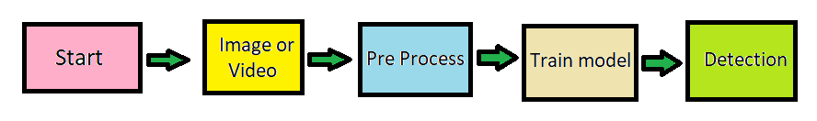

Block diagram of proposed approach[fig: 1]

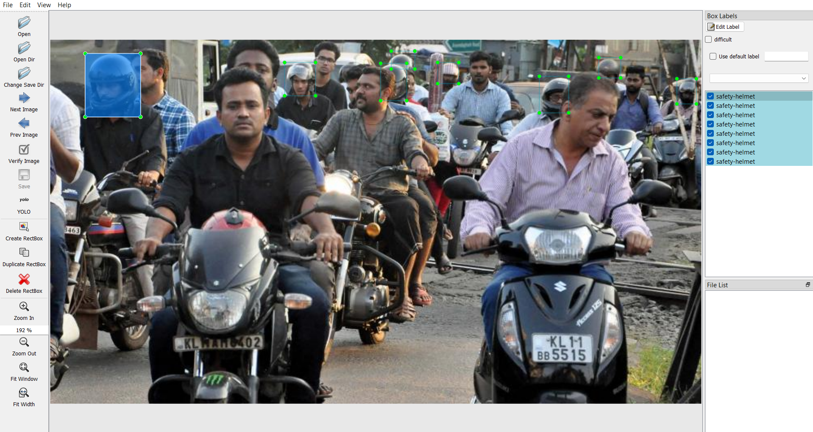 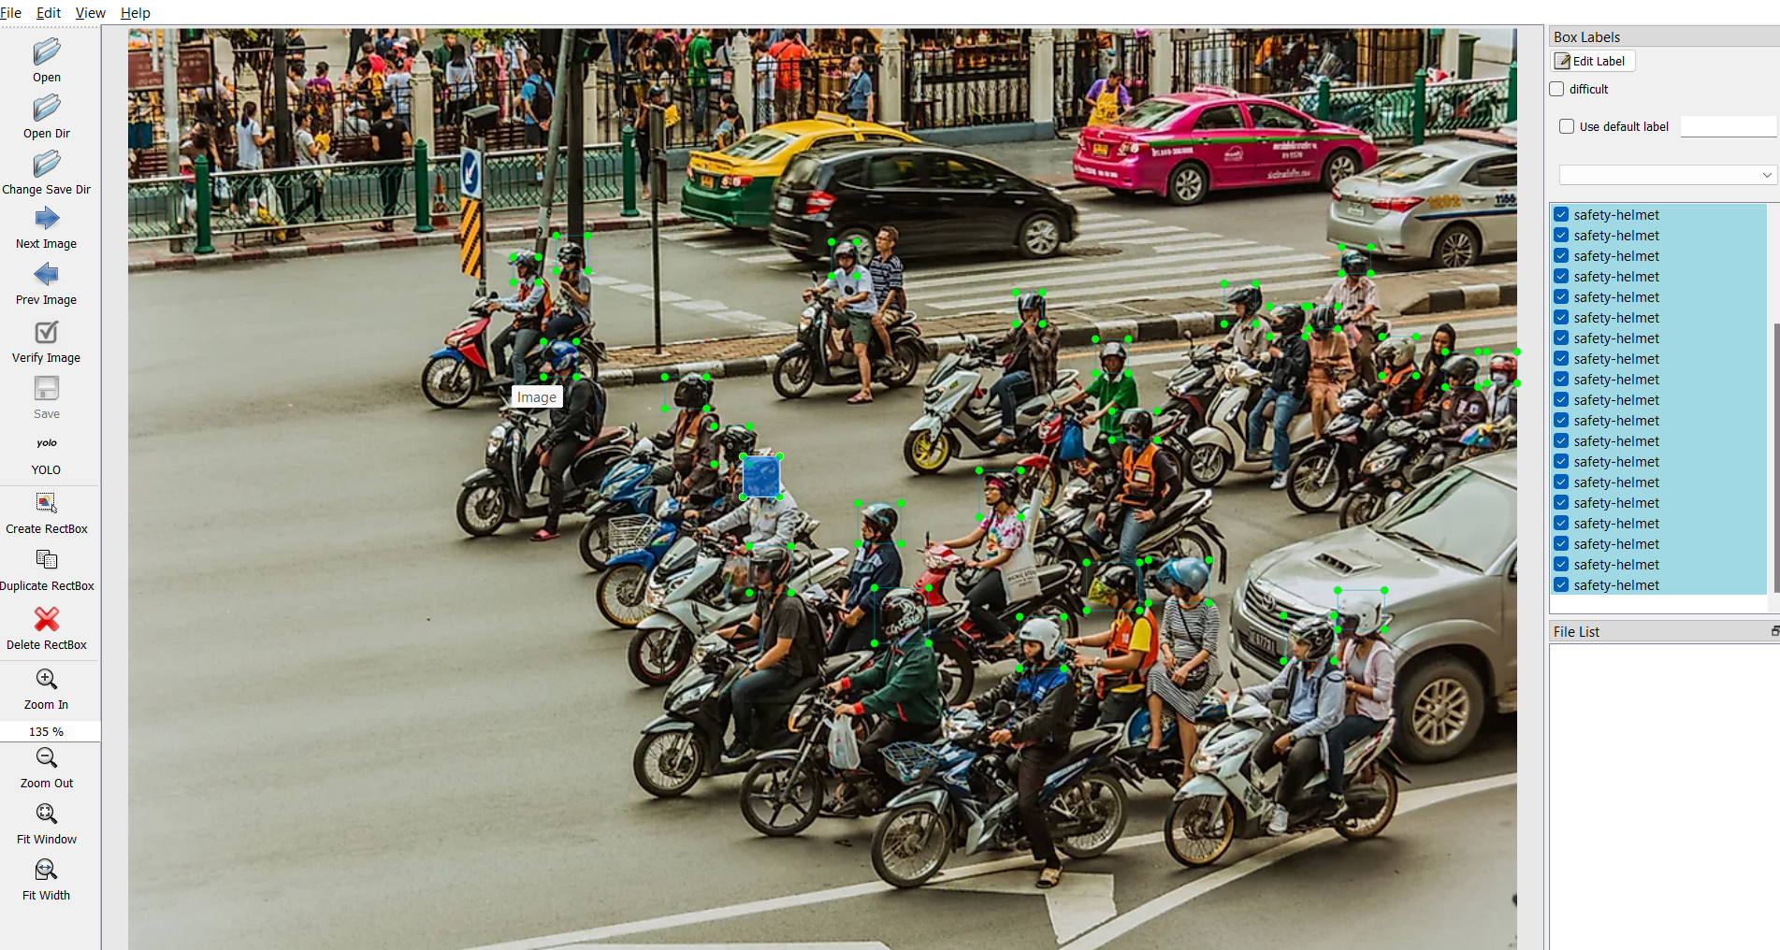

[fig: 1.1] [fig: 1. 2]

The basics of this approach relies on creating and forming a database of images and marking the object that the yolo model needs to be trained for which is then fed to the yolo algorithm for ‘n’ number of cycles(epochs) in order to let the algorithm gather enough information and data , which is then further used to detect objects in real time. Therefore, we begin by collecting enough pictures of various traffic situations and enough camera angles of the object that the model needs to be trained for. The images are then analyzed one by one physically and a coordinate system is developed capturing the required object in each of the images.

For this specific task of marking the object in the dataset images we use “***labelimg***” a simple application designed for the sole purpose of enclosing the objects in geometric shapes(rectangle in our case) and saving the coordinates of the rectangle in a .txt file. We then use this information i.e. files containing the images and their coordinate information respectively, into a .zip file , which is then further used in the yolo training process.

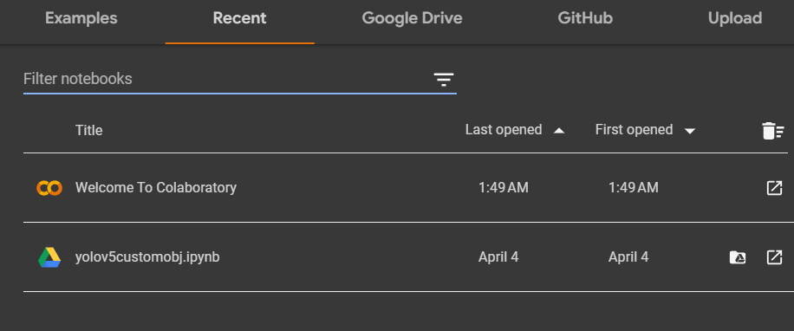[fig: 1.3]

Google colab is a free online tool that enable users to utilize jupyter notebooks to build and run python programs. For running machine learning models and data analysis tasks, it supplies a cloud-based environment with access to a virtual machine and free GPU and TPU assets. Anyone can use and keep their notebooks in google drive while using google colab , which makes it simple to share info and work with others. The use of strong machine learning frameworks like TensorFlow, PyTorch , and Scikit-learning is also possible, as is the installation and importation of python libraries. The production of live visualizations and more. Overall , Google colab is a useful and potent tool for anybody wishing to explore and build python code in online setting using the cloud .

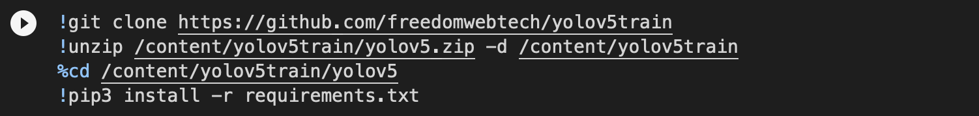

[fig: 2.1]

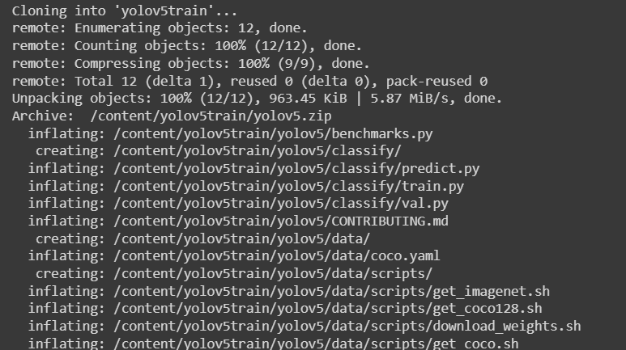

[fig: 2.2]

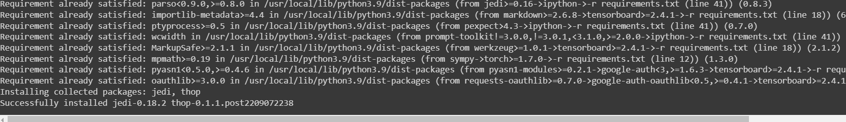

[fig: 2.3]

In this first snippet in the above image we import the yolov5 file required for training the model along with all its dependencies & other requirements.

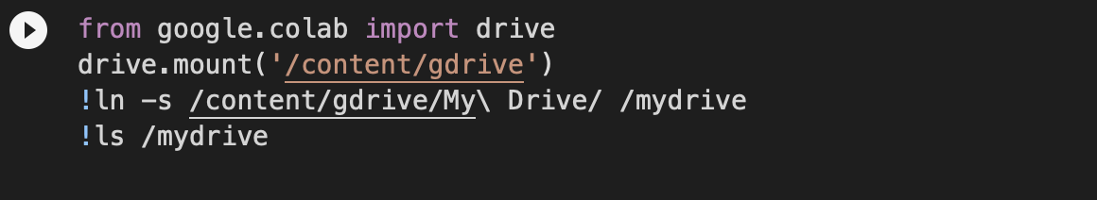

[fig: 3.1]

The ‘**.*zip*‘** data file , created post marking the images using ***labelimg*** is then uploaded to a Google Drive that is linked with the ***Google Colab*** account . In this snippet we mount the Google Drive & access the uploaded data file location .

 [fig: 3.2]

Here we simply unzip the data file which will be further required to train the Yolov5 model. Then we access the *dataset.yaml* file, which basically contains the class or classes which we have used to mark/denote the object(s) , and change the names of the classes(if needed).

 [fig: 3.3]

After running the above **yolov5s**.pt which we are showing in the above image . It will train AI from (0-99 epochs).And With each epoch the AI gets progressively trained which is reflected by the increment in the accuracy value.

[fig: 3.4]

Now, in Google colab click on Files >yolov5train >yolov5 >runs >train >exp >weights >best.pt and download ‘best.pt’ .

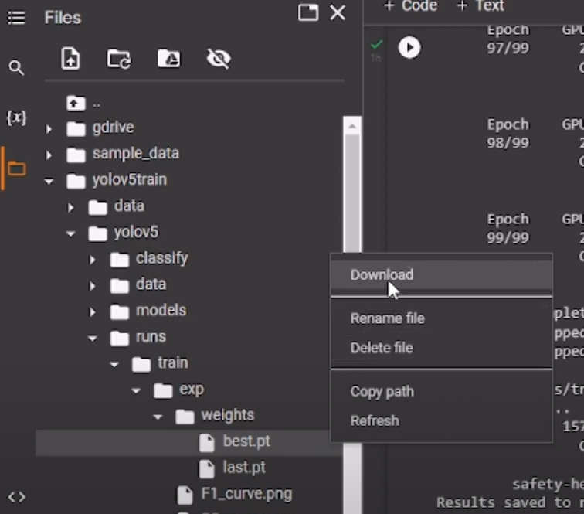

[fig: 3.5]

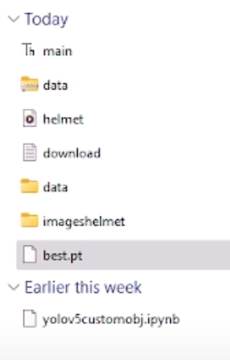

[fig: 3.6]

[fig: 3.6] is our required files and folders. We are using Thonny python platform to implement our code. We are using 3 libraries in our code.

1. **CV2:**

A popular open-source computer vision and image processing library is cv2 library, also known as OpenCV (Open Source Computer Vision Library). For tasks like image and video input/output, picture filtering, feature identification, object recognition, camera calibration, and more, it provides a complete collection of functions and algorithms. Python is one of the many programming languages for which bindings for import cv2 are available, so developers may use it in their projects. It is a crucial tool for computer vision researchers, developers, and hobbyists since it has a sizable user base and offers copious documentation and training.

1. **TORCH :**

‘PyTorch’, often known as the ‘torch’ library, is a powerful open-source machine learning framework. It offers a broad range of functions for jobs like setting up and training neural networks, working with tensors, putting deep learning methods into reality, and doing effective GPU calculations. The dynamic computational graph and automated differentiation features of ‘import torch’ make it simple for users to create and test sophisticated deep learning models. ‘PyTorch’ is user-friendly interface, thorough documentation, and support for cutting-edge features like networked computing have helped it become extremely well-known in the scientific and business worlds. For many academics and practitioners of machine learning, it has emerged as a go-to resource.

1. **NUMPY AS NP:**

‘numpy’ library, a potent tool for numerical computation, by using the import ‘numpy’ as np command. Large, multidimensional arrays and matrices are supported, and a wide range of mathematical operations are available to effectively work with these arrays. It is simpler to refer to the functions and objects of the ‘numpy’ module in your code if you use the as np component, which enables you to use the abbreviation np as an alias for the ‘numpy’ module. Numerous array operations, calculations using linear algebra, statistical analysis, and other tasks may all be carried out with ‘numpy’. It is a key component of the ecosystem for scientific computing and is extensively utilized in disciplines including simulation, machine learning, and data analysis.

CODE PART:

# import required libraries

import cv2

import torch

import numpy as np

# set the path to the pre-trained YOLOv5 model

path1='A:/project/yolov5safetyhelmet-main/best.pt'

# load the YOLOv5 model using torch.hub

model1 = torch.hub.load('ultralytics/yolov5', 'custom',path1, force_reload=True)

# open the input video file using OpenCV VideoCapture

cap1=cv2.VideoCapture('helmet.mp4')

# initialize a variable to count the frames processed

count=0

# loop through the video frames until there are no more frames left

while True:

# read the next frame from the video file

ret,frame=cap.read()

# if there are no more frames, exit the loop

if not ret:

break

# skip every third frame to reduce the processing load

count += 1

if count % 3 != 0:

continue

# resize the frame to the required size for the YOLOv5 model

frame=cv2.resize(frame,(860,660))

# use the YOLOv5 model to detect objects in the frame

results=model(frame)

# render the results onto the frame and convert it to a numpy array

frame=np.squeeze(results.render())

# display the frame in a window titled "My DataSet"

cv2.imshow("FRAME",frame)

# if the user presses the "Esc" key, exit the loop

if cv2.waitKey(1)&0xFF==27:

break

# release the video capture object and destroy any OpenCV windows

cap1.release()

cv2.destroyAllWindows()

**4.Result Analysis:**

**Training & Results:**

Using the Labelling tool, the training procedure involves manually labelling the pictures designated class objects. It will give us the class label back. The studies are carried out on Google Colab using a browser on a computer with an NVIDIA GeForce RTX 3050 GPU and Intel Core i7-10750H processor running at 2.6 GHz and 16 GB of system RAM. We observed that the accuracy in every epoch is changing rapidly.

**Graph :**

**Line Graph:**

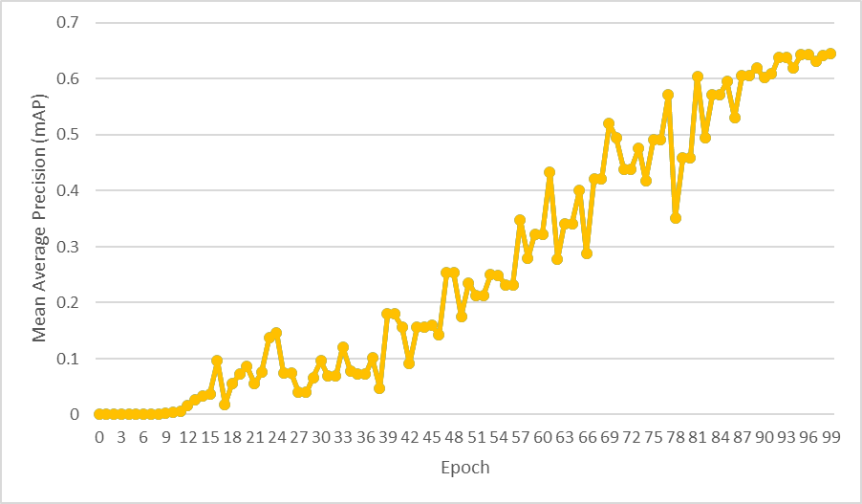

**Accuracy Increase in Training part**

The detected helmet can be seen in Fig. 4.1,4.2,4.3 along with the bounding boxes for each class ,after running the code in Thonny python platform.

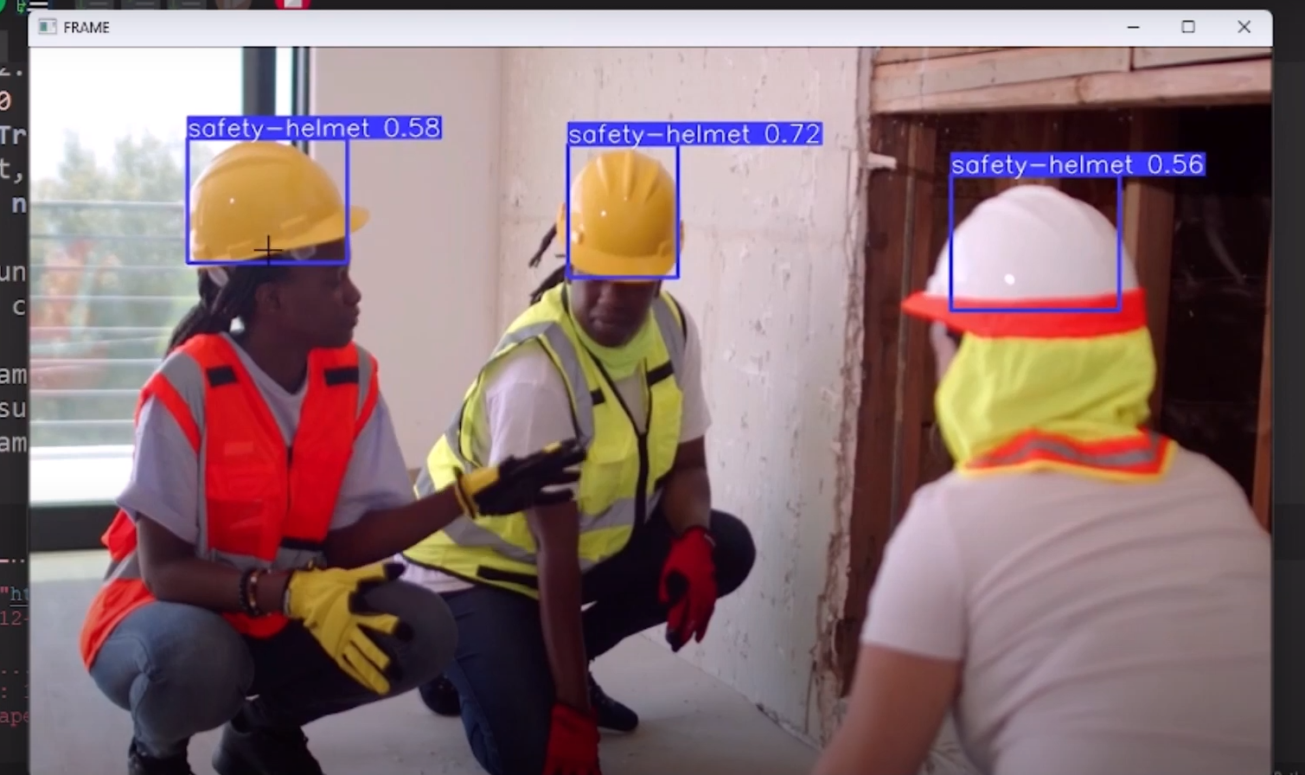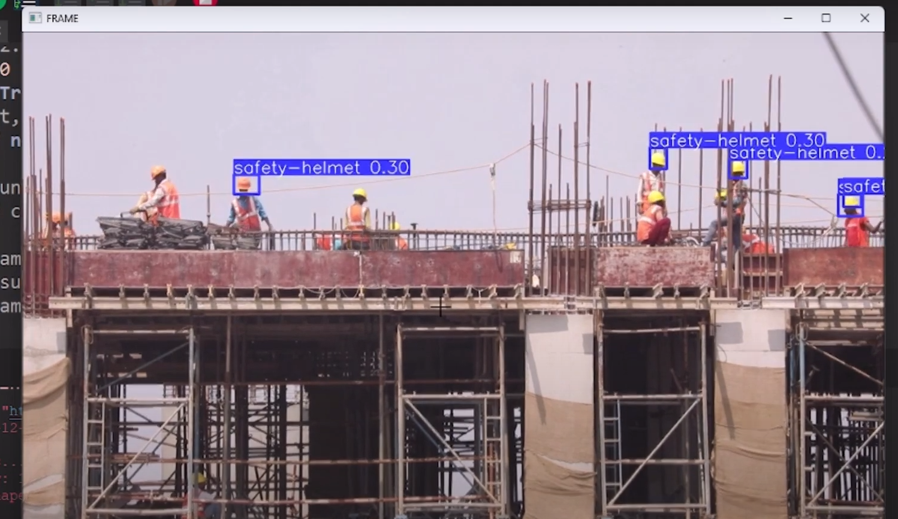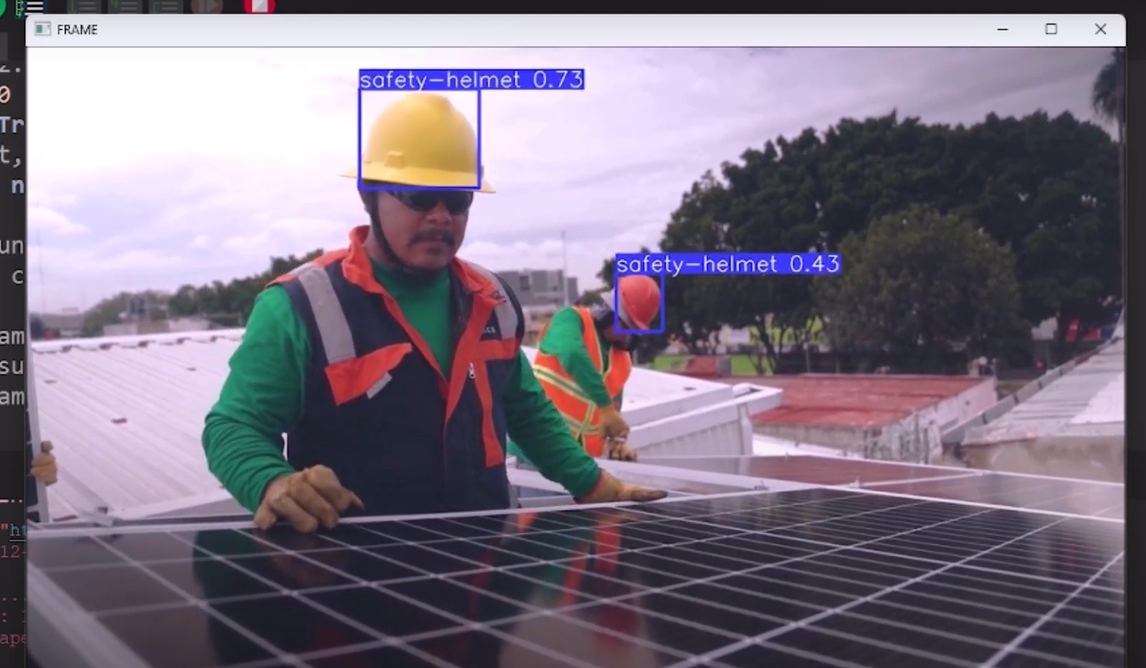

[fig: 4.1] [fig: 4.2] [fig: 4.3]

**5.Conclusion:**

According to the data shown above, it is clear that YOLOv5 object detection is well suited for real-time processing and was successful in correctly classifying and localizing all object types. The suggested end-to-end model contains all the necessary components to be automated and deployed for monitoring, and it was successfully constructed. Once equipped with top-notch machinery, this system will be able to provide even more accuracy than the existing prototype. In the near future, further study may be done to identify and make the system operate with various camera angles. Just enough of the present dataset remains to create a functional prototype model. The primary goal of the project was to address the issue of ineffective traffic management. Now we are working on it to improve this model .